Progress Report of this week:

In the last week, we basically focused on learning and writing HTML, CSS and Bootstrap. We have designed basic frontend layout for our project, which is shown in following image.

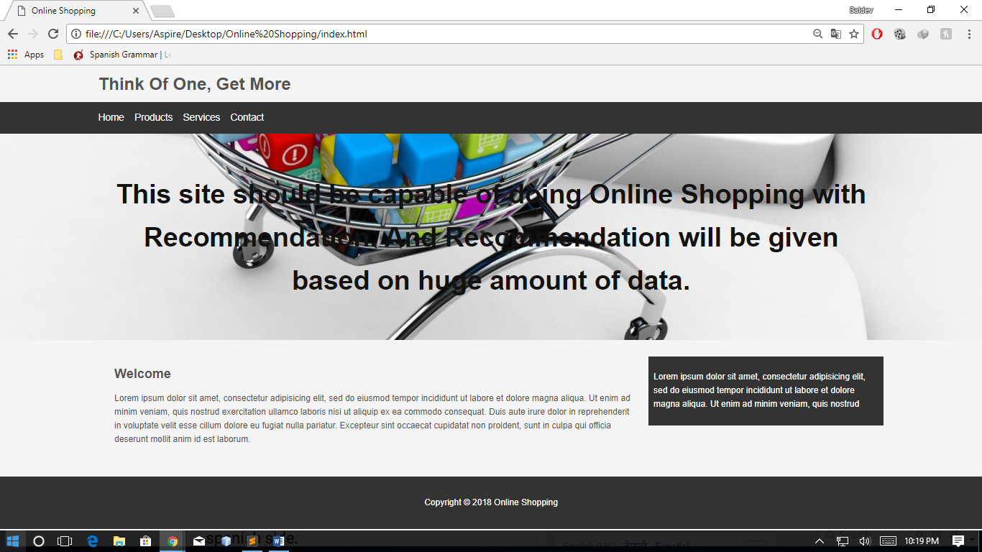

Initially, we had planned to use JSP and java for backend programming but now we changed our mind to use ASP.NET. The reason behind changing backend programming language is that the time frame available for doing our project is limited.

We initiated our project with frontend programming and is still in progress. As we were working on basic designing part of our project, we faced only minor challenges, which we successfully resolved. For the next week, we are planning to improve our layout & design and also initiate backend programming.

Sincerely,

Baldev Bhattarai

Denish Kayastha

Rajan Shrestha